Photography By Emmy Lee
Wedding Contract (937)763-0385

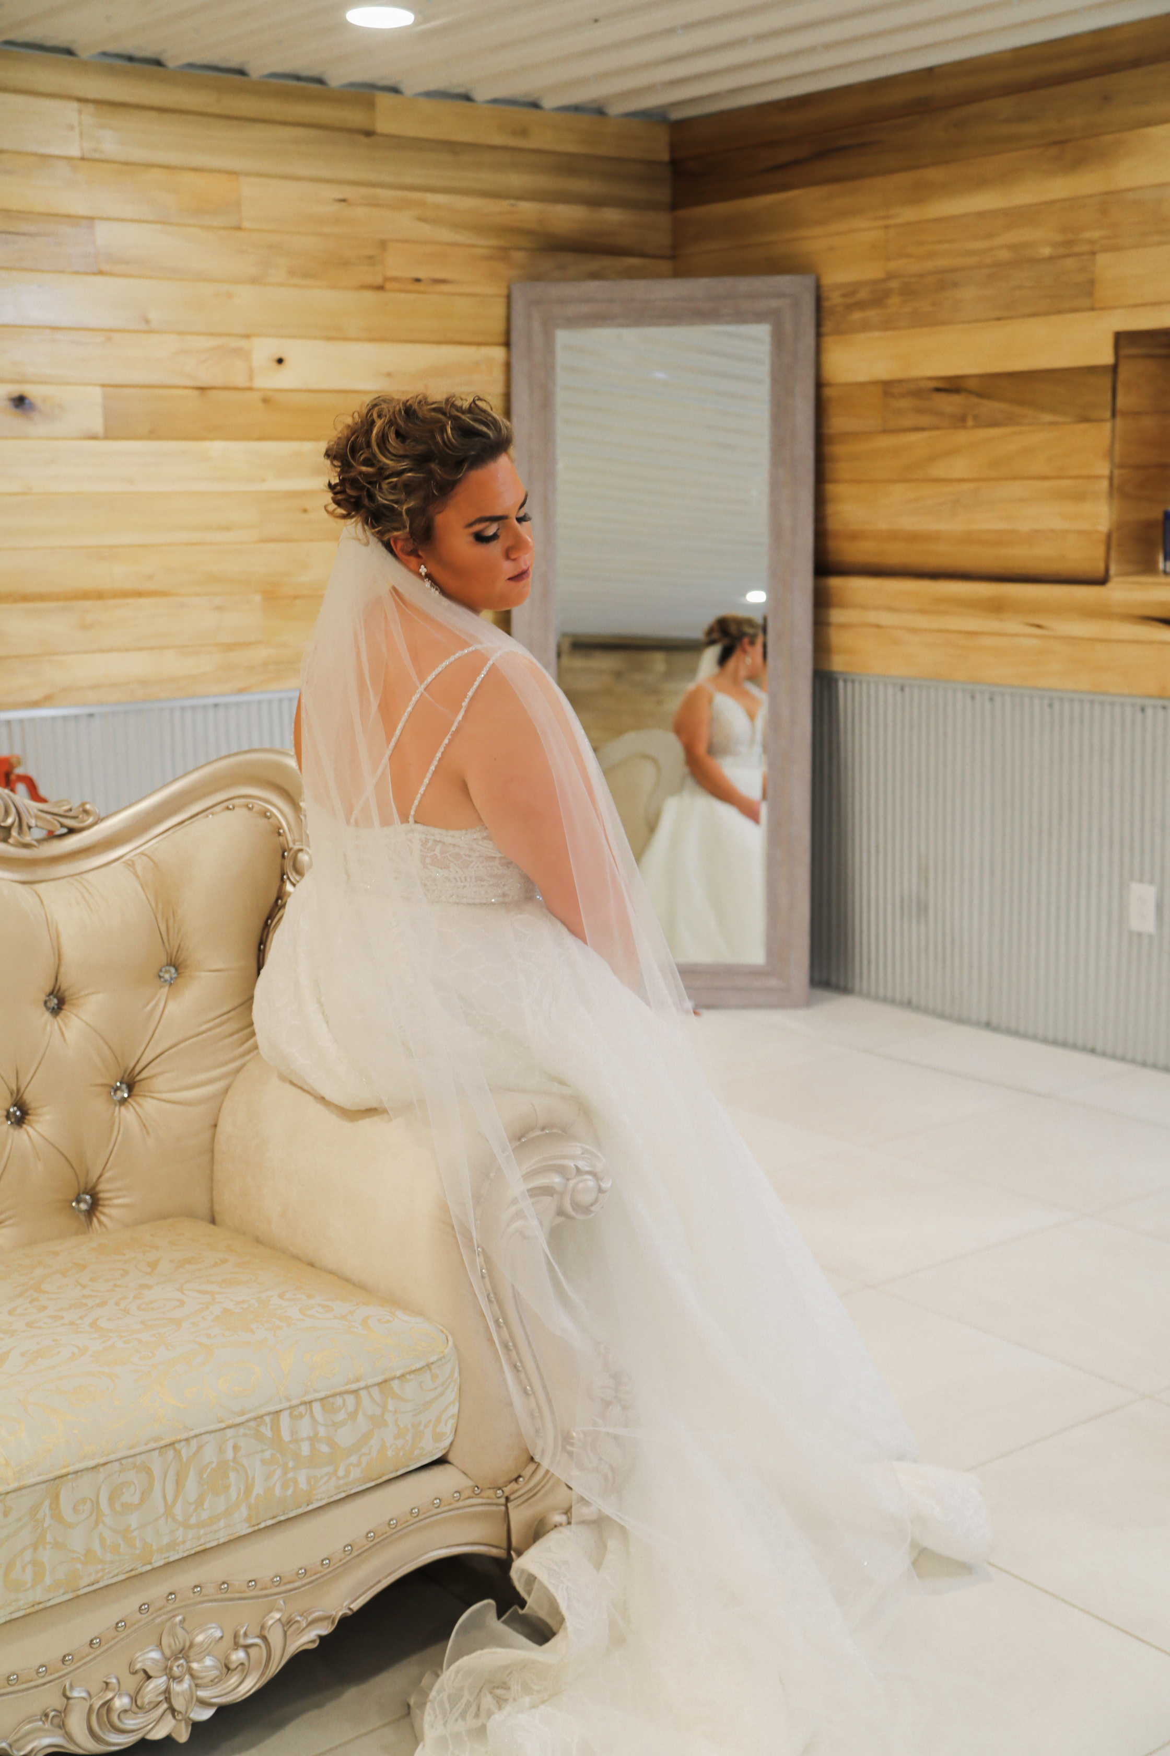
If the photographer cannot perform this agreement in whole or part due to a cause beyond the control of the parties, (such as illness or injury), then the photographer will return all fees to the client(s) but shall have no further liability with respect to this agreement. This limitation on liability shall also apply in the event that photographic materials are damaged in processing, lost through camera malfunction, lost in the mail, or otherwise lost or damaged without fault on the part of the photographer.
- On signing of this agreement by both parties, the photographer will reserve the time agreed upon and will not make another reservation for the specific time frame. For this reason, all deposits are non-refundable even if the date is changed or if the wedding becomes cancelled for any reason. If the wedding is cancelled for any reason and photographer is give 30 days or less of notice, you will be responsible for paying the rest of the cost for the wedding.
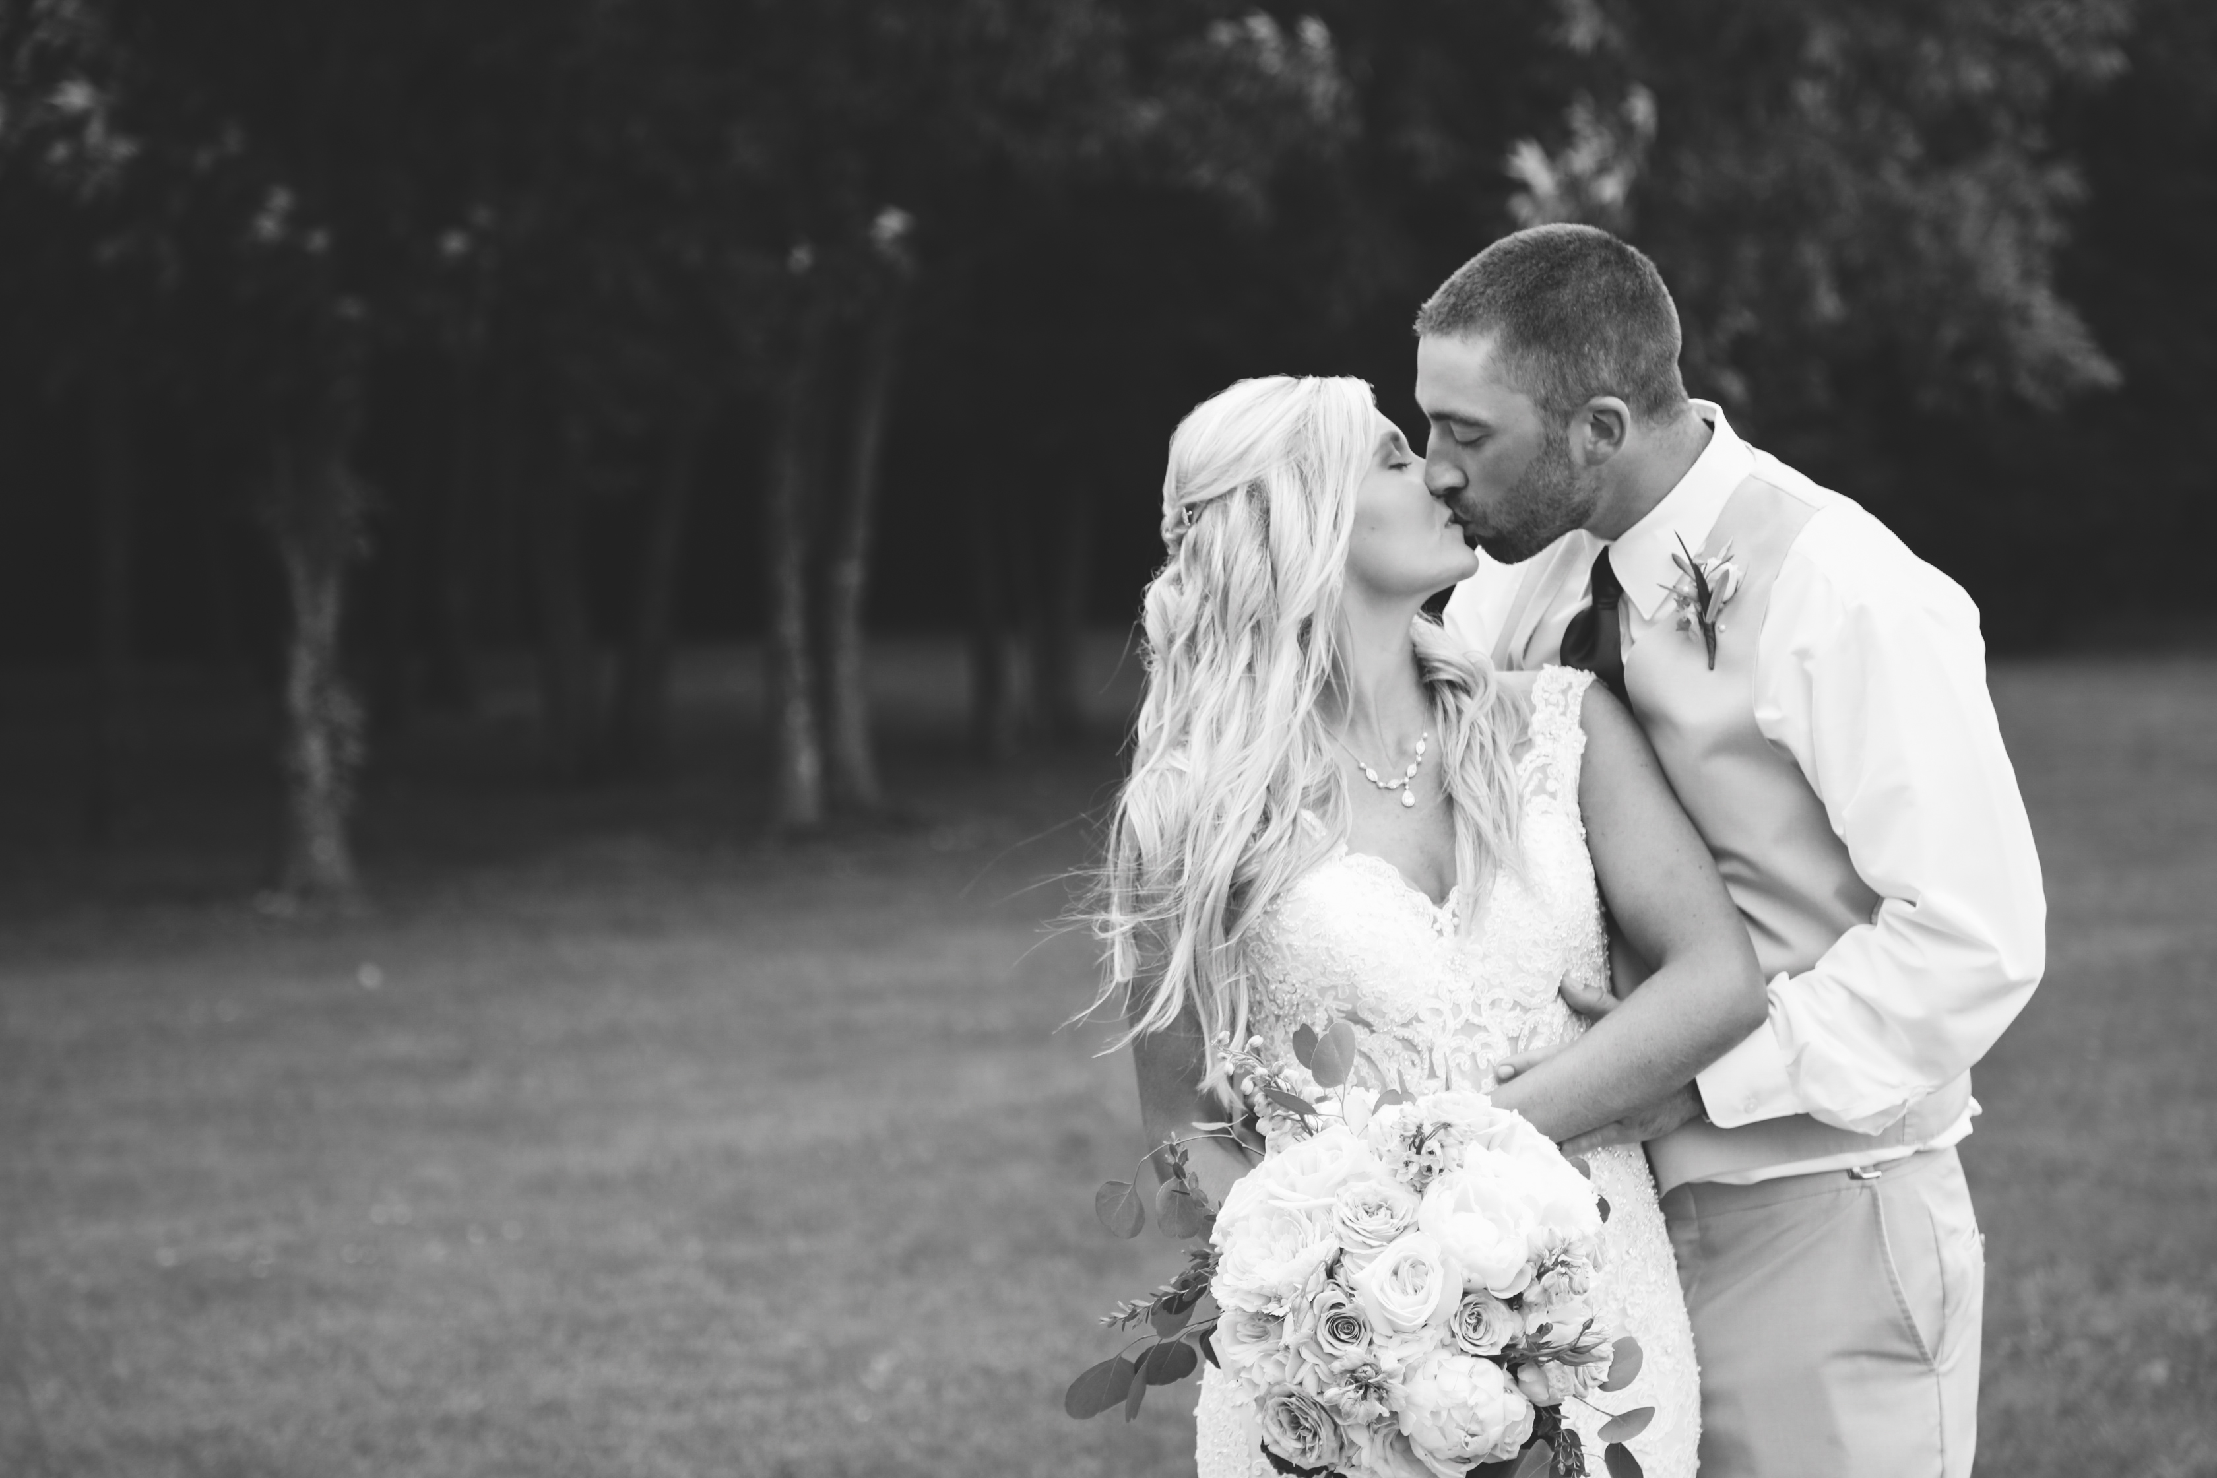
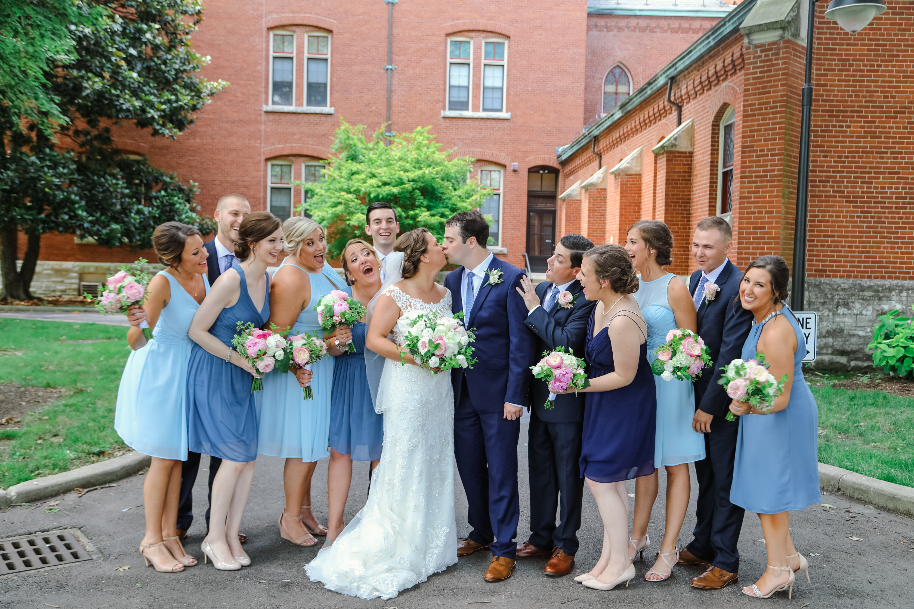
- I do allow other family members and friends of yours to take pictures during the wedding. However, under some circumstances having other “photographers” at the wedding can be a distraction to myself, the bride and groom, and the wedding guests. Because of my photojournalistic style of wedding photography, I am skilled in remaining unobtrusive, and I use that to capture the most authentic moments possible. Please be aware that this may not be the same for other photography enthusiasts or photographers that you have taking pictures at your event. I leave it up to your discretion whether or not you will allow other photographers to shoot at your wedding, but I can not guarantee the same quality of images at a wedding where another photographer is getting in the way during important and meaningful parts of the wedding. Usually this can be avoided by explaining to any other photographers that you are getting all of the full resolution images that I shoot at your wedding, so photographing the same exact situations will end up with redundant images.

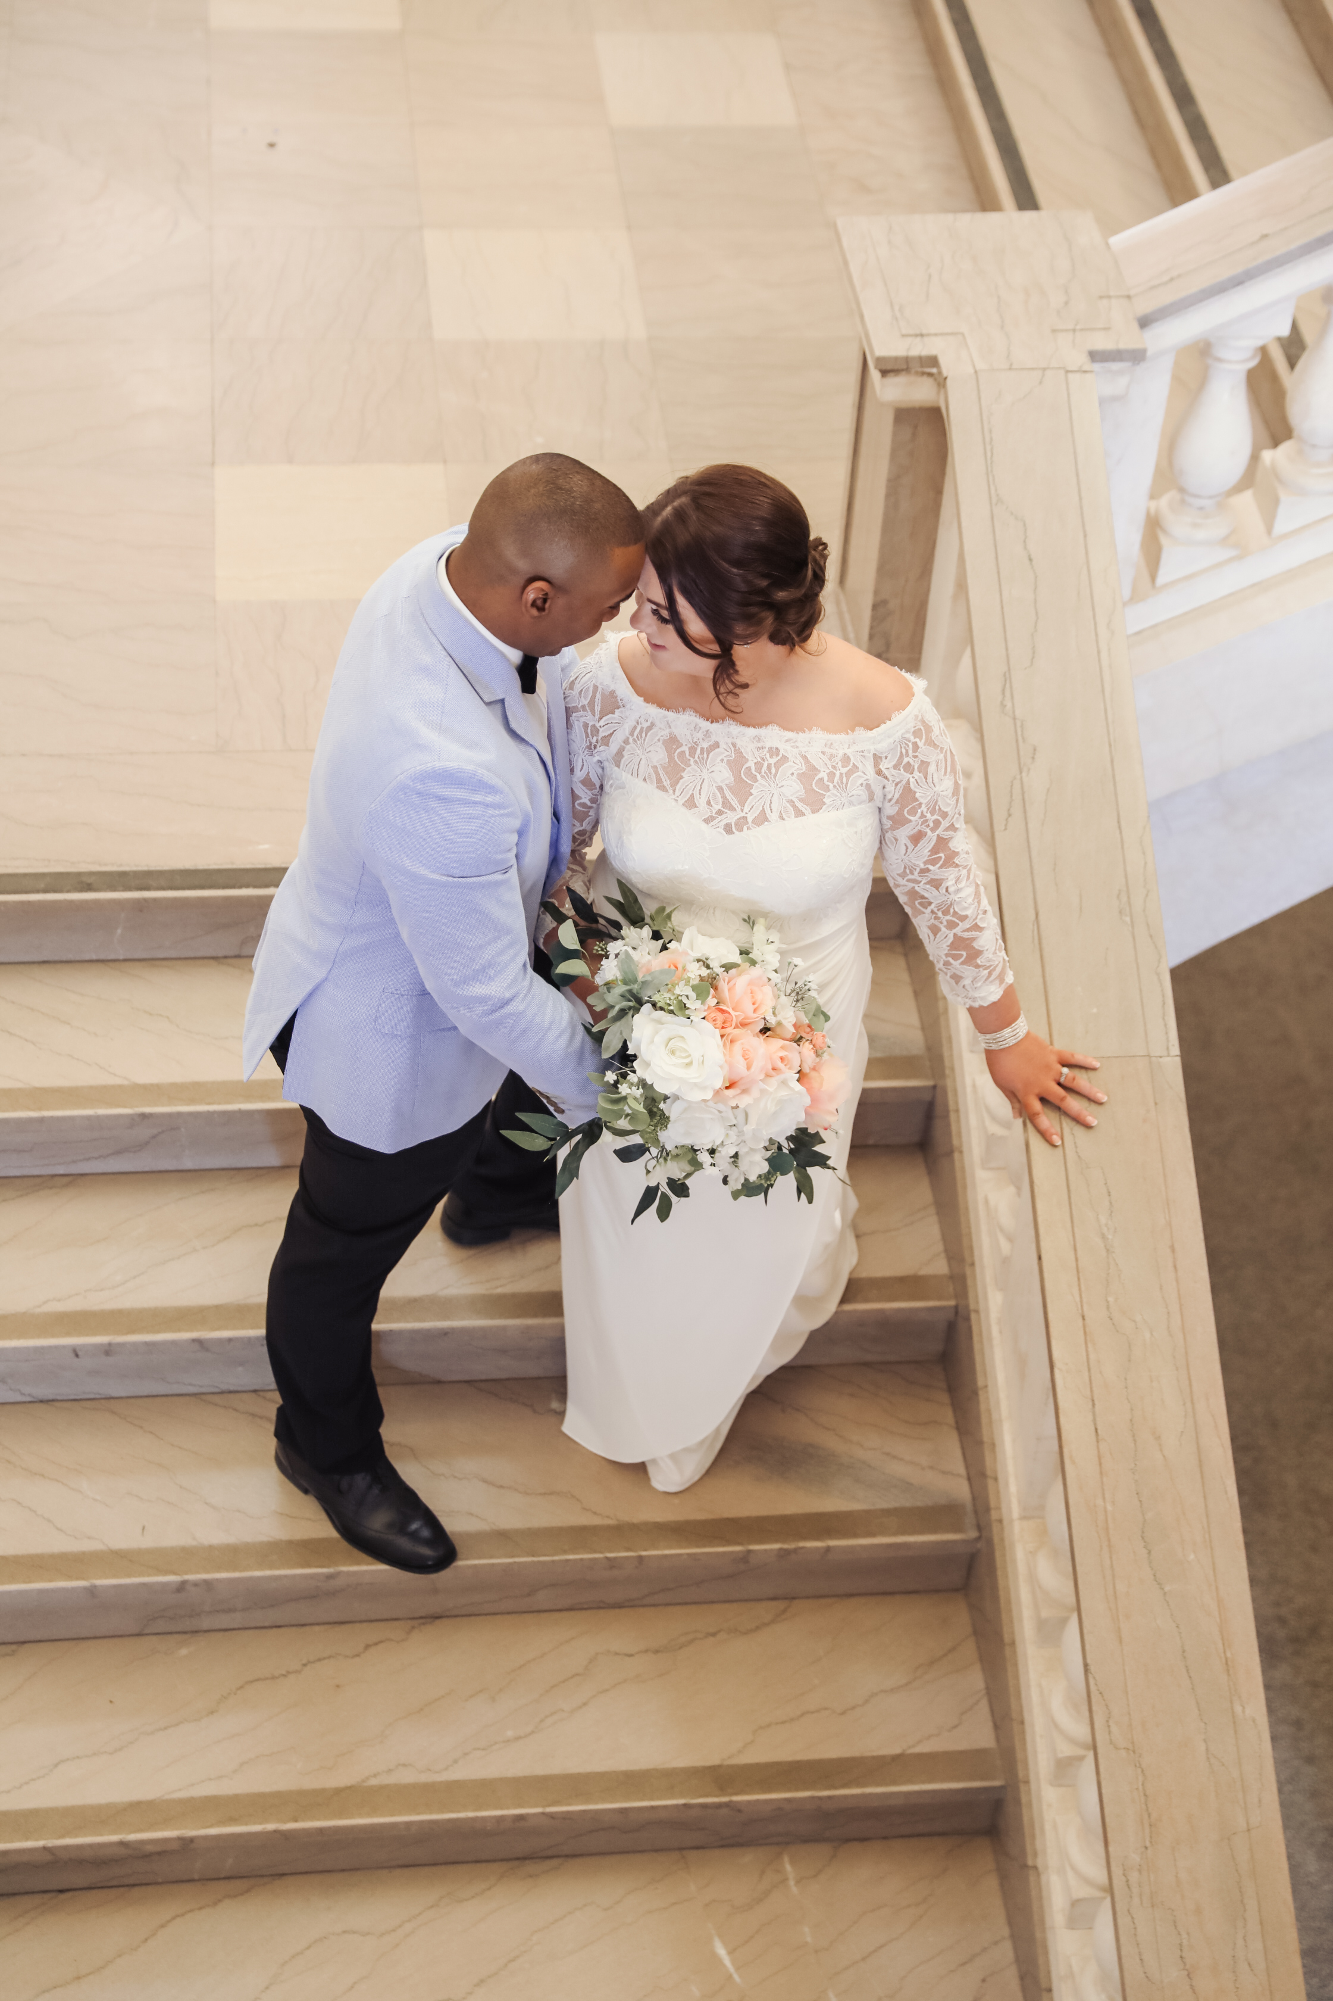

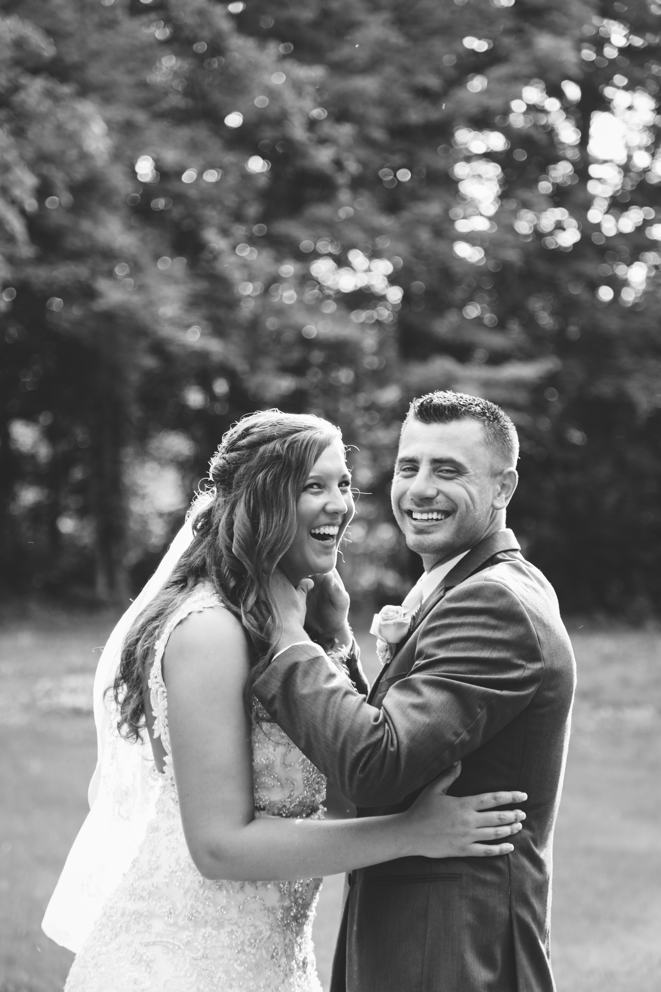
- Copyrights: Until final payment for services rendered is made, all photographs produced by the Photographer are protected by Federal Copyright Law (all rights reserved) and may not be reproduced in any manner without the photographer’s explicitly written permission. The photographer is allowed to use images taken under this contract for self promotion, including, but not limited to: web site advertising, print advertising, sample albums and packages, photography contests, and art displays. Upon final payment by the Client, limited copyright ownership of the resulting images is allowed to the Client under the following conditions:
- The digital images and / or prints are the property of the Client for personal use and for the purposes of the reproduction and giving of photographs to friends and relatives.
-You will have written permission to use your jump drive anywhere
-You will have a USB jump drive with all photos from your day.
- All terms and conditions still apply for my other employees, that work for me.

Bride and Groom’s Name___________________________________________________
Home Street Address:______________________________________________________
Street Address Continued:__________________________________________________
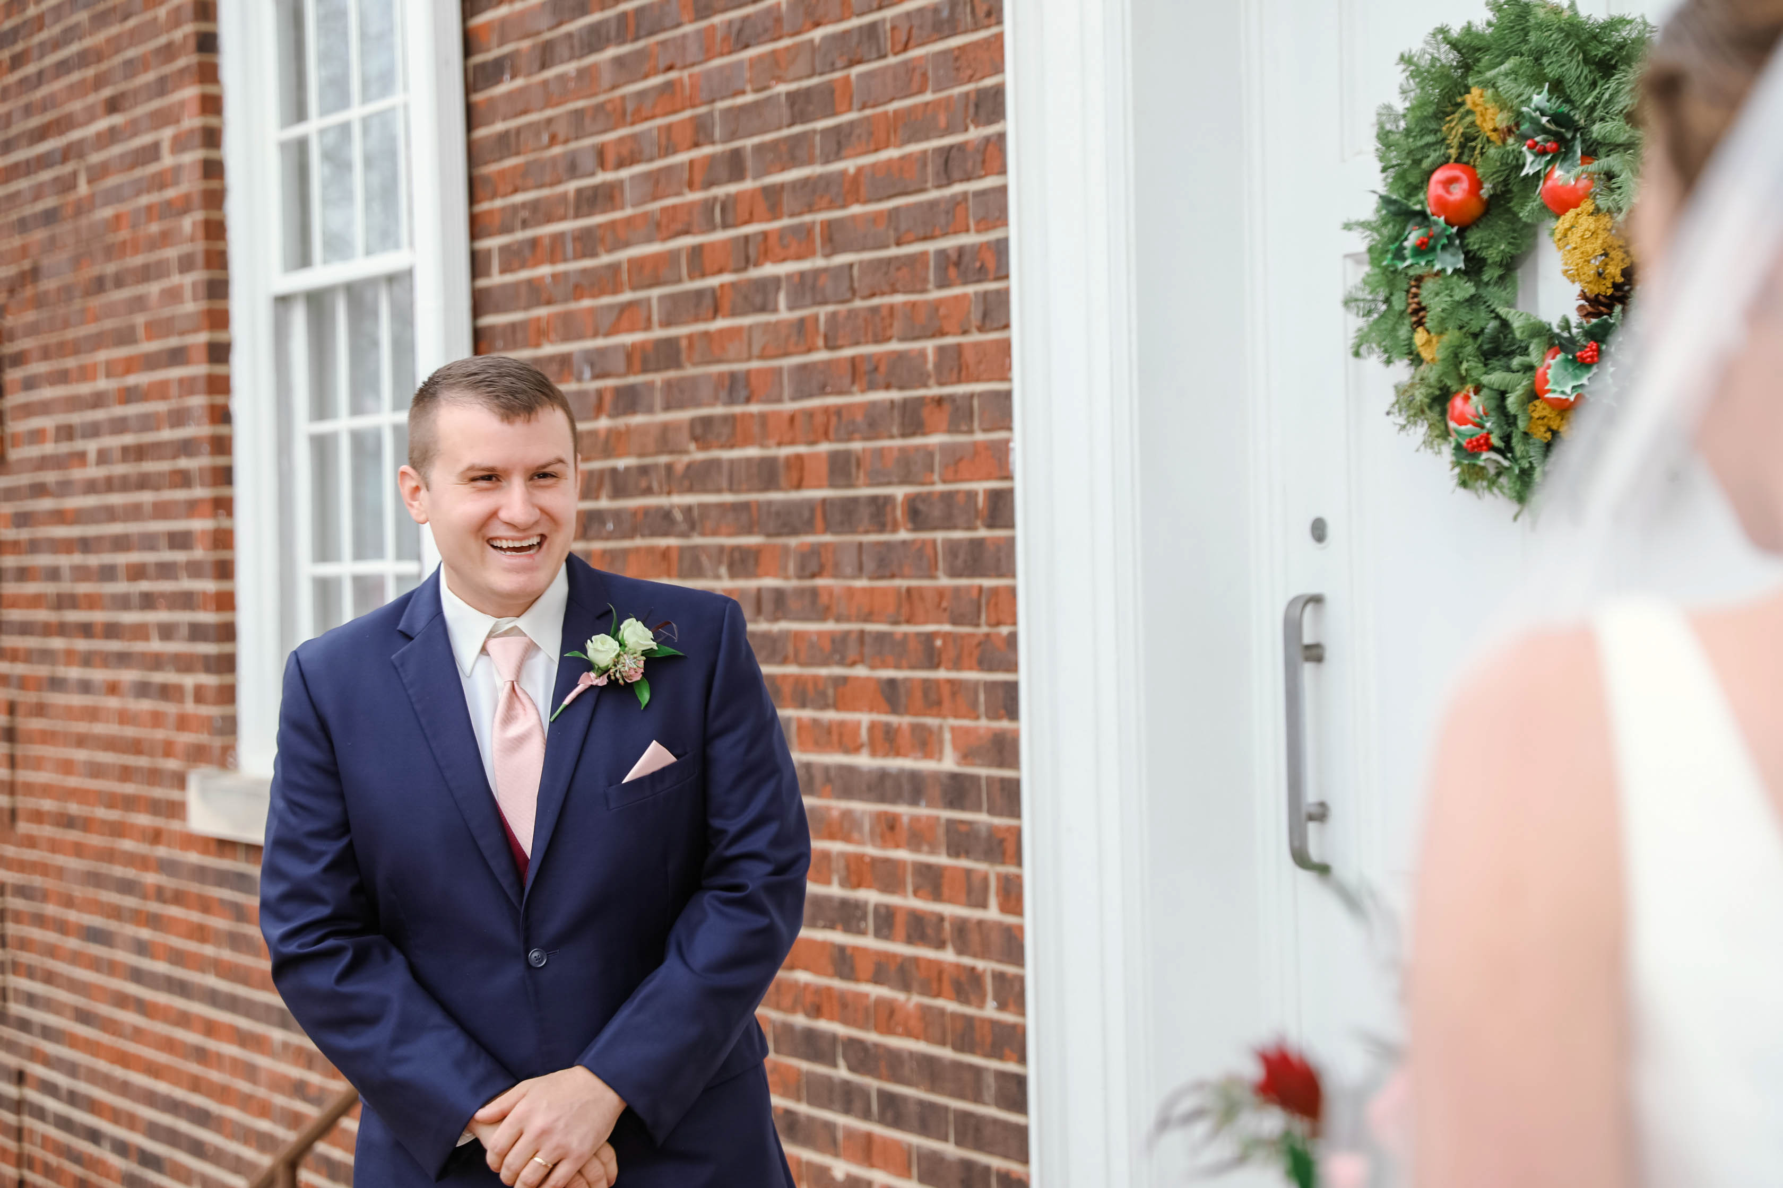
City:_______________ State:_____ Zip Code:___________
Home Phone:__________________
Cell Phone:___________________
E-mail:__________________________________
Wedding Day Details:
Wedding Date:______________________
Wedding Location:__________________________________________________________
Reception Location_________________________________________________________
Desired time of arrival:______________________
Emergency Wedding Day Contact: Name_______________ Phone_______________
The non-refundable deposit will be paid at the time of signing this contract. It will be applied towards the total balance.
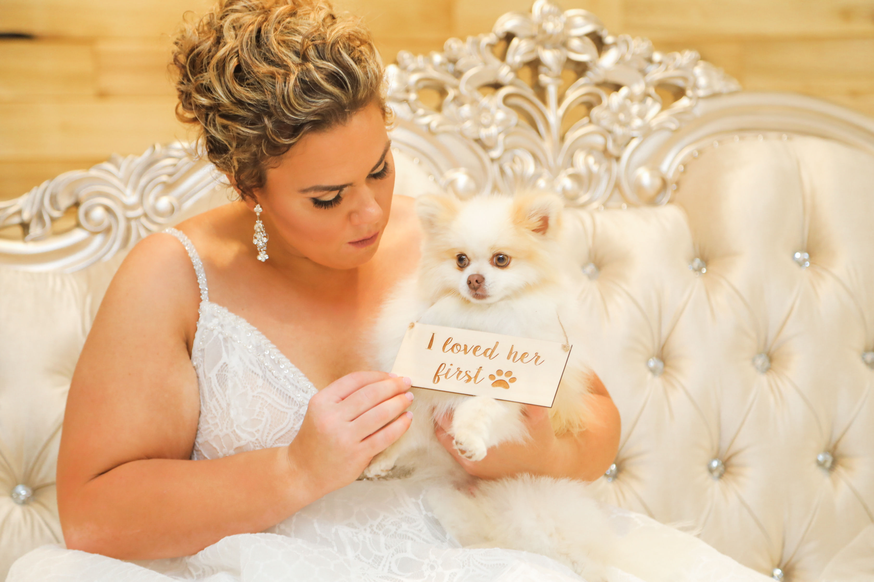
The total payment of ________________ will be paid in full by the date of the wedding. Usual turn around is 6-8 weeks. To rush photos for deliver in seven days it is an extra $300.00.

- I/ we, the undersigned Contracting Party, hereby warrant that I am/ we are competent to contract in my / our own name(s). I/we confirm that I / we have read the herein agreement prior to its execution and I / we are fully familiar with the contents thereof. This agreement shall be binding upon us and our heirs, legal representatives and assigns. And, we certify that we have received a complete copy of this agreement.
Signature____________________________________________ Date_____________
Signature___________________________________________
By signing above I am stating that I have read and accept all of the above terms of the Wedding Contract agreement with Photography By Emmy Lee.
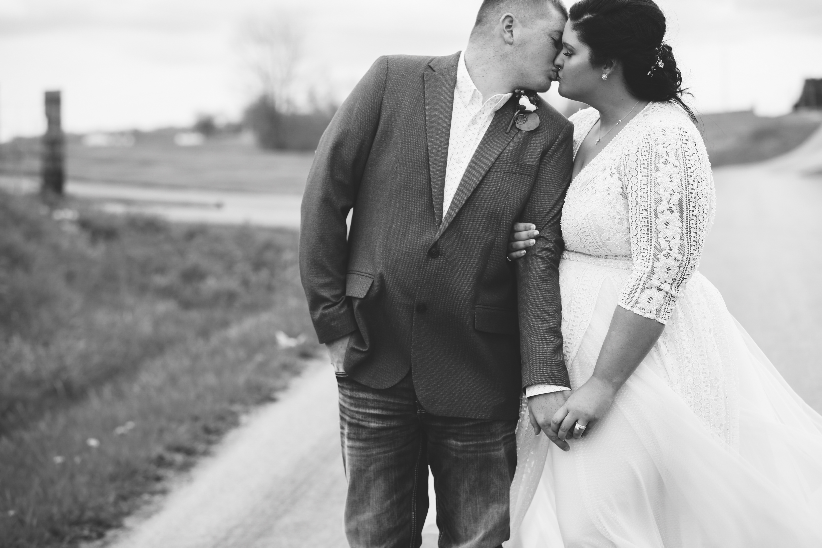
Photographer’s Signature_______________________________ Date____________
Emmy Woods
www.photographybyemmylee.com
100 E Lilley Ave Hillsboro Ohio 45133
(937)763-0385

